Algebra 1 Name ________________________________________
Functions
- One of the reasons we work with algebraic expressions is to model situations using functions.
- A _________________ is defined as a relation in which ______________________________________________________.
**Think of a vending machine….

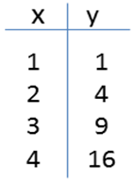
-Relations can be represented in multiple ways:
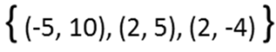
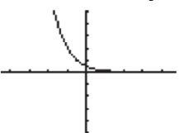
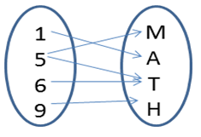

- In a function, the set of the values of the inputs is called the _____________________ and the set of values of the outputs is called the __________________.
- Function Notation: in an equation, use _____________ in place of “y”.
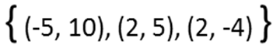
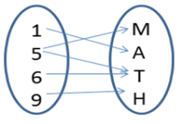

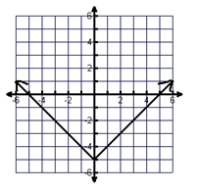
Use the graph of the function to identify the input or output.
Inputs: ___________________
f(-4) = If f(x) = -2, then x = _______
f(0) = If f(x) = 0, then x = _______
f(2) = If f(x) = 1, then x = _______
Outputs: _________________

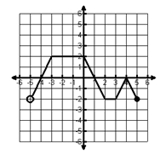
f(-1) = If f(x) = 1, then x = _______
f(2) = If f(x) = 0, then x = ____________
f(-5) = If f(x) = -2, then x = _______

Inputs: ___________________________
Outputs: _________________________
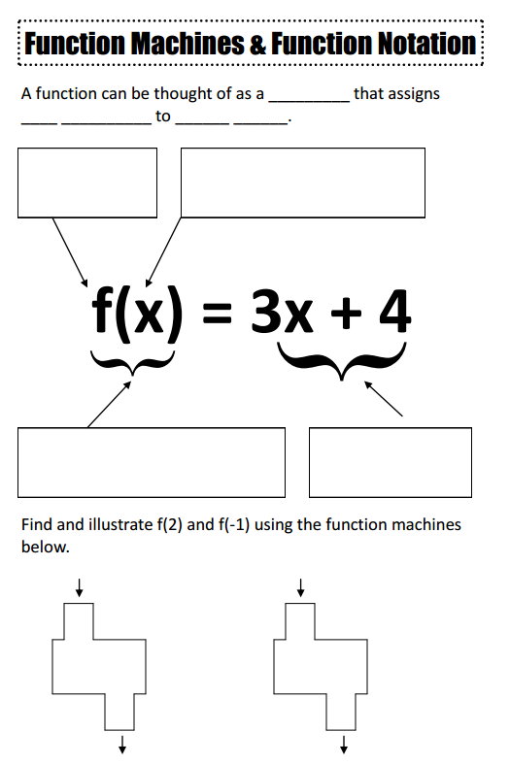
PRACTICE
Let f(x) = x² + 3 and g(x) = x + 1. Find the following values:
1. f(3) = 2. g(3) = 3. f(2) + g(1) =

4. (f-g)(x) = 5. 5$∙$f(1)= 6. f(2) - g(-6) =

Let k(x) = -3x+1
7. If k(x) = -14, then x = __________ 8. If k(x) = -5, then x=______________

Function vs. Not a Function
Vertical line test: a graph is a function if it _______________ the vertical line test
- Tell if the following are functions or non-functions. Use vertical line test!
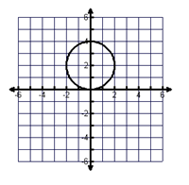
1) Function? 2) Function?
Why? Why?

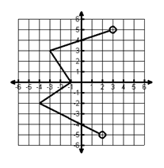
3) Function? 4) Function?
Why? Why?

Are the following functions? Be able to explain why or why not.
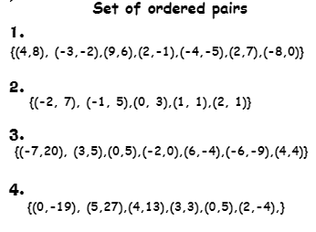 Function? ________________
5
-8
1
0
5
7
9
-3
Why? ___________________________

